

NAME: BISMA FATIMA
CLASS: CS A
ROLL NO: F24605036
COURSE: COMPUTER NETWORK
COURSE CODE: CS-271
LECTURER: SIR NAVEED YOUSAF

LAB 05

Performing Dynamic Router Configuration
Warm up Task
Answer each question in your own words (3 to 4 lines)
1. What is Dynamic Routing?
Dynamic routing is a network technique where routers automatically learn and update paths to different destinations. It uses routing protocols to adapt to changes in the network, like link failures or new connections, without manual configuration.

2. Key Features of Dynamic Routing
- Automatically updates routing tables.
- Adapts to network changes in real-time.
- Uses metrics like hop count or bandwidth to choose paths.
- Supports large and complex networks efficiently.

3. How It Works
Routers exchange information using routing protocols. They calculate the best path based on metrics and update their tables regularly. If a route fails, they quickly find an alternative route using updated data.

4. Types of Dynamic Routing Protocols
- RIP (Routing Information Protocol)
- OSPF (Open Shortest Path First)
- EIGRP (Enhanced Interior Gateway Routing Protocol)
- BGP (Border Gateway Protocol)

5. Difference Between Static and Dynamic Routing
Static routing requires manual setup and doesn’t change unless updated by an administrator. Dynamic routing adjusts automatically to network changes, making it more flexible and scalable for larger systems.

6. Full Form of RIP and Main Purpose
RIP stands for Routing Information Protocol. Its main purpose is to help routers determine the best path to a destination using hop count, making it suitable for small to medium-sized networks.

7. Key Characteristics of RIP
- Uses hop count as the routing metric.
- Maximum hop count is 15; anything beyond is unreachable.
- Sends updates every 30 seconds.
- Simple to configure and maintain.

8. How RIP Works
RIP routers share their entire routing tables with neighboring routers every 30 seconds. Each router selects the shortest path (least hops) to reach a destination and updates its table accordingly.

9. Advantages and Disadvantages of RIP
Advantages:
- Easy to set up and manage.
- Works well in small networks.
Disadvantages:
- Limited to 15 hops, restricting scalability.
- Slow convergence and periodic updates can cause delays.

Task 1
By using Drag and drop draw the topology diagram as shown below and attach a screenshot of each step.
1. Pc
2. Switch (2950-24)
3.Router (Generic-PT)
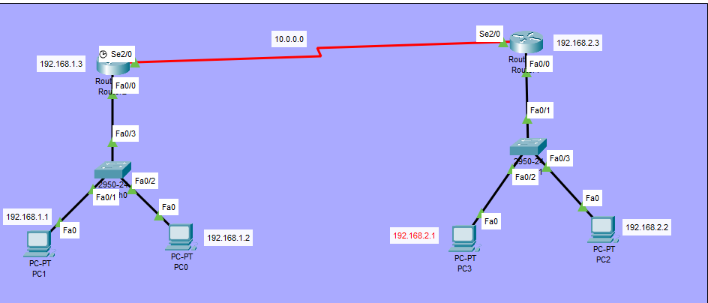
Figure 1. Packet Tracer Topology Diagram

Basic Router configuration on R1
1. Continue with configuration dialog? [yes/no]: no
2. Press RETURN to get started! Press enter button
3. Router>en (enable)
4. Router#config t (configure terminal)
5. Router(config)#int fa0/0 (interface FastEthernet0/0)
6. Router(config-if)#ip address 192.168.1.3 255.255.255.0
7. no shut (no shutdown)
8. Router(config-if)#exit
9. Router(config)#
10. Router#config t
11. Router(config)#int se2/0 (Interface Serial2/0)
12. Router(config-if)#ip address 10.0.0.2 255.0.0.0
13. no shut (no shutdown)
14. exit
15. exit
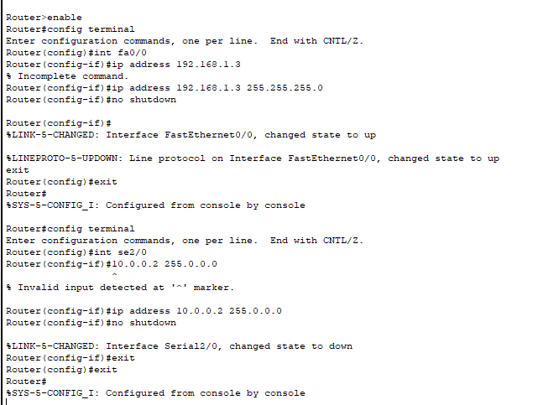

Show ip interface brief for R1
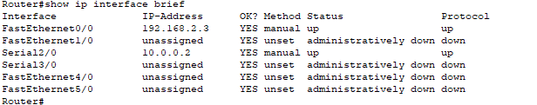

RIP Implementation on Router 1 Side
(After implementation all above 15 command )
Router> enable
Router# configure terminal
Router(config)# router rip
Router(config-router)# version 2
Router(config-router)# network 192.168.1.0
Router(config-router)# network 10.0.0.0
Router(config-router)# exit
Router# write memory
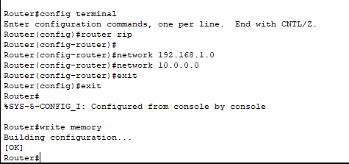

Show ip protocol for R1
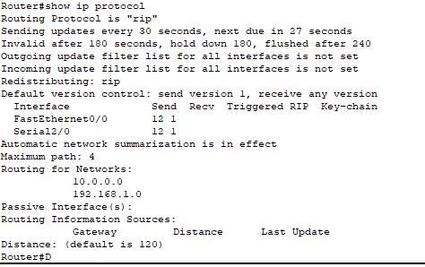

2. Basic Router configuration on R2 Side
1. Continue with configuration dialog? [yes/no]: no
2. Press RETURN to get started! Press enter button
3. Router>en (enable)
4. Router#config t (configure terminal)
5. Router(config)#int fa0/0 (interface FastEthernet0/0)
6. Router(config-if)#ip address 192.168.2.3 255.255.255.0
7. no shut (no shutdown)
8. Router(config-if)#exit
9. Router(config)#
10. Router#config t
11. Router(config)#int se2/0 (Interface Serial2/0)
12. Router(config-if)#ip address 10.0.0.1 255.0.0.0
13. no shut (no shutdown)
14. exit
15. exit
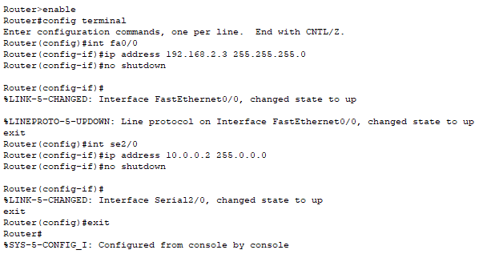

Show ip interface brief foe R2


RIP Implementation on Router 2 Side
Router> enable
Router# configure terminal
Router(config)# router rip
Router(config-router)# version 2
Router(config-router)# network 192.168.2.0
Router(config-router)# network 10.0.0.0
Router(config-router)# exit
Router# write memory
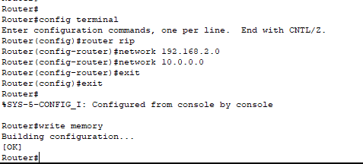
Show ip protocol for R2
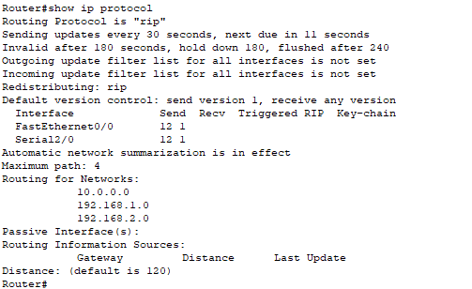

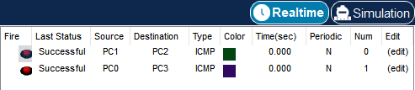

Task 2:
Draw given topology diagrams and attach screen shots of Pcs communication
- Label each device with a unique ip address.
- Highlight different sections
- Divide given topology in three different networks
- Ping one laptop to other network laptops.
- Send packets (Real time).
- Send packets(Simulation).
- Take screen shots of routing table of each router
- Take screen shots of routers configurations
- implement Rip through command line on each router configuration

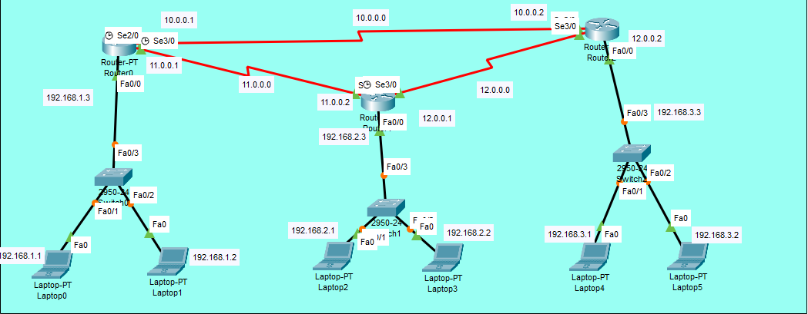
Figure 2. Task 2 Draw Topology diagram implement RIP on Each

ROUTER 01
Basic Router configuration on R1
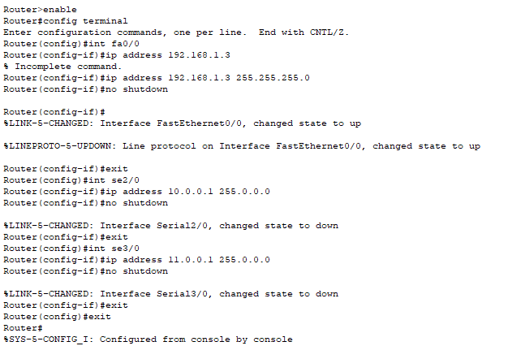

RIP Implementation on Router 1 Side
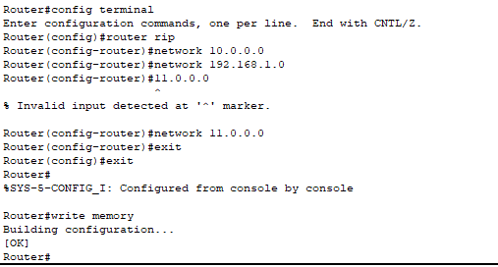

Show ip protocol for R1
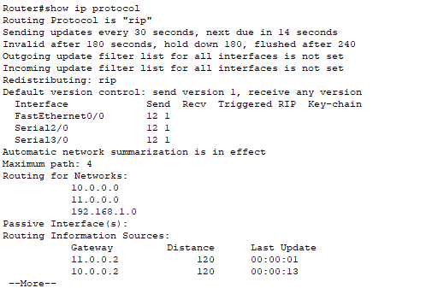

Show ip interface brief for R2
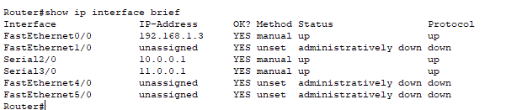

Show ip route for R1
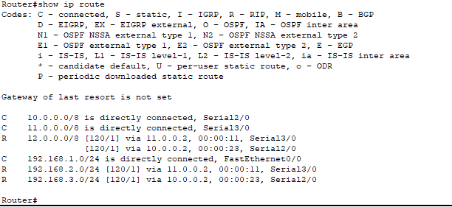

ROUTER 02
Basic Router configuration on R2
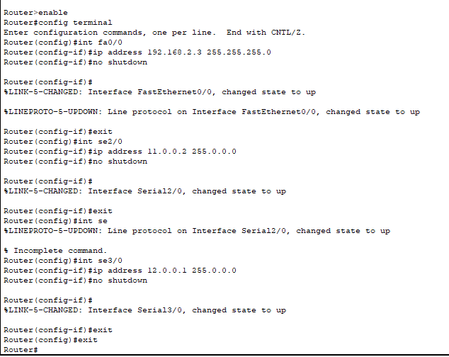

RIP Implementation on Router 2 Side
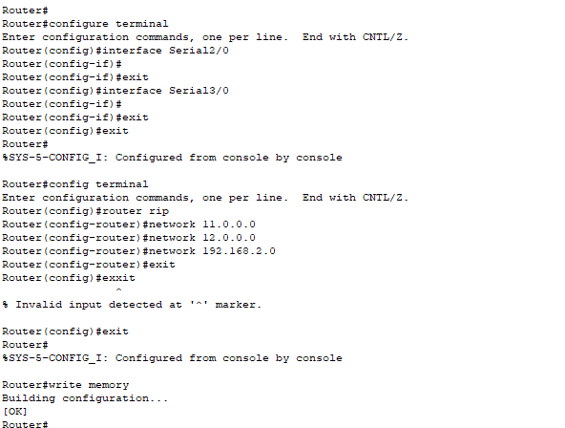

Show ip protocol for R2
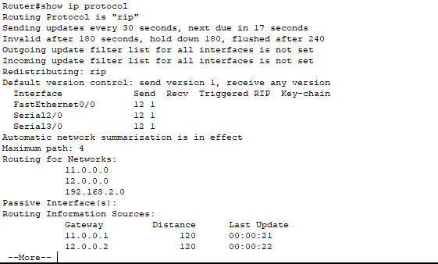

Show ip route for R2
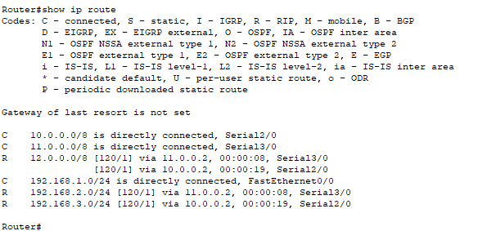

Show ip interface brief gor R2
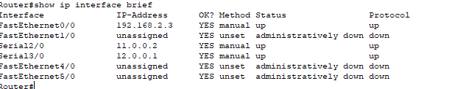

ROUTER 03
Basic Router configuration on R3
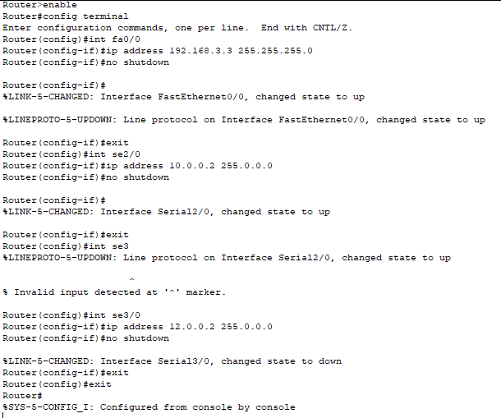

RIP Implementation on Router 3 Side
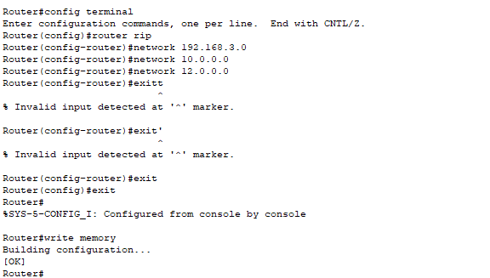

Show ip route for R3
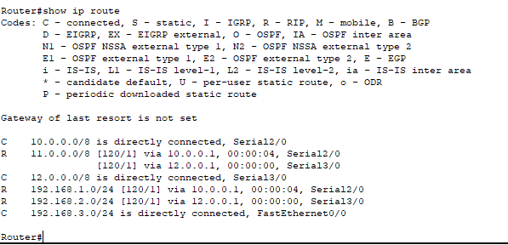

Show ip protocol for R3
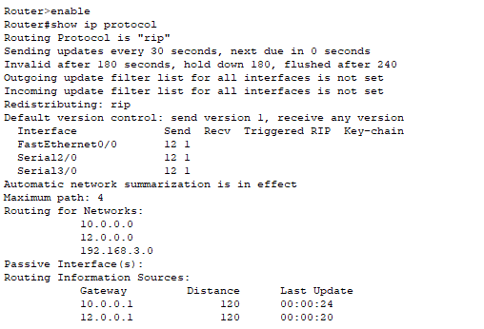

Show ip interface brief for R3
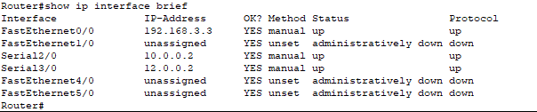

Ping one laptop to other network laptops.
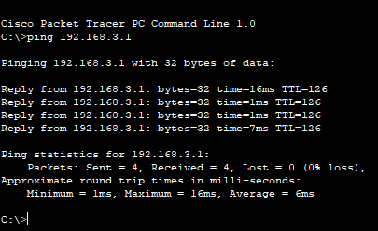

Send packets (Real time).
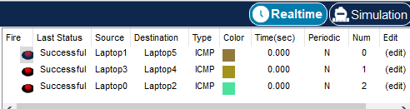

Send packets(Simulation).
